# HPDE Assets

(SPASE, Metadata, IHDEA, HAPI)

Revised: 2021-Jul-29

# Web sites:

    spase-group.org

Host location: Github.com

Host platform: Static pages

Domain Registration: domain.com under Todd's account

Domain Expiration: 2026-07-07

Source location: <https://github.com/spase-group/website>

Build process: Run "grunt" in home directory, folder "docs" shared to github.io.

Administrator: Todd

Site Role: All information about SPASE, location of information model spec.

    ihdea.net

Host location: Github.com

Host platform: Static pages

Domain Registration: domain.com under Todd's account

Domain Expiration: 2023-10-20

Source location: <https://github.com/IHDE-Alliance/ihde-alliance.github.io>

Build process: Repo shared to github.io.

Administrator: Todd

Site Role: All information about IHDEA.

    spase.info (Deprecated - no longer maintained)

Host location: UCLA/IGPP

Host platform: Tomcat 7 on metal

Domain Registration: joker.com. I think Ed Bell created the original registration.

Domain Expiration: 2023-09-14

Source location: <https://github.com/IHDE-Alliance/ihde-alliance.github.io>

Administrator: Todd

Site Role: Public registry of SPASE metadata and landing pages for DOI.

    hpde.io

Host location: Github.com

Host platform: Static pages

Domain Registration: domain.com under Todd's account

Domain Expiration: 2025-06-24

Source location: <https://github.com/hpde/hpde.io>

Build process: Repo shared to github.io. Pages generated with the tools in https://github.com/spase-group/spase-generate-pages

Administrator: Todd

Site Role: Public registry of SPASE metadata and landing pages for DOI.

    Hapi-server.org

Host location: Github.com

Host platform: Static pages

Domain Registration: godaddy.com. I think Jeremy Faden created the original registration.

Domain Expiration: 2024-05-16

Source location: <https://github.com/hapi-server>

Administrator: Jon/Jeremy

Site Role: All information about HAPI server spec.

# Mailing lists

    hapi-dev

Host location: groups.io

URL location: <https://groups.io/g/hapi-dev/topics>

Administrator: Todd

List Role: Information related to the development of the HAPI spec.

    hapi-news

Host location: groups.io

URL location: <https://groups.io/g/hapi-news/topics>

Administrator: Todd

List Role: Public announcements.

    hpde-repo

Host location: groups.io

URL location: <https://groups.io/g/hpde-repo/topics>

Administrator: Todd

List Role: Information from GitHub actions performed on repos.

    ihdea-dev

Host location: groups.io

URL location: <https://groups.io/g/ihdea-dev/topics>

Administrator: Todd

List Role: Information related to IHDEA development.

    ihdea-executive

Host location: groups.io

URL location: <https://groups.io/g/ihdea-executive/topics>

Administrator: Todd

List Role: Notices and discussion for the IHDEA executive board.

    ihdea-member

Host location: groups.io

URL location: <https://groups.io/g/ihdea-member/topics>

Administrator: Todd

List Role: Notices for IHDEA members.

    ihdea-news

Host location: groups.io

URL location: <https://groups.io/g/ihdea-news/topics>

Administrator: Todd

List Role: Public announcements.

    spase

Host location: groups.io

URL location: <https://groups.io/g/spase/topics>

Administrator: Todd

List Role: Information related to the development of the SPASE information model.

# SPASE web tools

   Validator

URL location: <http://spase-group.org/tools/validate/>

Host platform: Tomcat 7 on metal

Language: Java and JSP

Source location: <https://github.com/spase-group/registry-services>

Administrator: Todd

Model spec document generator

Host platform: Command line (Windows or Linux)

Language: Node.js

Source location: <https://github.com/spase-group/spase-model-tools>-node

Administrator: Todd

 Model spec document generator (deprecated)

Host platform: Command line (Windows or Linux)

Language: Java and SQL

Source location: <https://github.com/spase-group/spase-model-tools>

Administrator: Todd

   Metadata editor (SMWT)

URL location: <http://spase-group.org/tools/validate/>

Host platform: LAMP web server in a container.

Language: HTML/Javascript and PHP

Source location: IGPP internal Gitlab (git.igpp.ucla.edu/spase/xmleditor)

Administrator: Todd

   Schema (Deprected)

URL location: <http://spase-group.org/tools/model/schema/>

Host platform: Tomcat 7 on metal

Language: XML Schema

Source location: IGPP internal Gitlab (git.igpp.ucla.edu/spase/website2)

Administrator: Todd

Registry explorer (Deprecated)

URL location: <http://spase-group.org/smwg/explorer/> (tree)

<http://spase-group.org/registry/explorer/> (tree)

<http://spase.info> (responsive and landing pages)

Host platform: Tomcat 7 on metal

Language: Java

Source location: <https://github.com/spase-group/registry-services>

Administrator: Todd

SPASE School (put in SPASE editor context?  Rethink?  Videos?)

URL location: <http://spase-group.org/school/>

Host platform: HTML/Javascript static pages

Language: XML Schema

Source location: https://github.com/spase-group/spase-school

Administrator: Todd

# NPM packages

spase-resource-tools

Description: Tools to validate and scan SPASE metadata.

Install: npm install -g spase-resource-tools

Administrator: Todd

Contents:

**spase-collate** : Separate each SPASE resource description in a file into a separate file stored in a folder tree according to the Resource ID.

**spase-refcheck** : Check resource identifiers and URLs for referential integrity.

**spase-validate** : Validate a SPASE resource description using a specified version of the data dictionary (XML schema).

**spase-tree** : List the file tree. Optionally list only files with a given extension.

**spase-update-authority** : Change the control authority in the ResourceID, add a PriorID and update ReleaseDate.

**spase-doi-ref** : Extract reference information in CSV format from a SPASE resource description.

**spase-doi-request** : Extract information from a SPASE resource description and generate a DataCite formated DOI request that can be submitted through EZID web service API.

**spase-list-elem** : List an element value in an XML document.

**spase-restamp** : Update the to the current data and time.

**spase-pretty** : Make a pretty XML file by formating the XML file with indentation and wrapping.

**spase-transform** : Transform a SPASE description in XML using an XML Stylesheet.

spase-model-tools

Description: Tools to generate information model PDF, JSON and XSD files.

Install: npm install -g spase-model-tools

Administrator: Todd

Contents:

**spase-model-xsd** : Generate the XML schema document to match the information model specification.

**spase-model-json** : Generate the JSON data files to match the information model specification.

**spase-model-pdf** : Generate PDF documentation for the information model.

# Documents (Conventions)

Source Location: Todd's desktop. PDF versions included in SPASE website repository.

Parameter Key Formation for Plain Text Data

Describes Parameter Key formation rules for describing simple tabular plain text files.

Data Model Version Numbers

Describes how versions numbers are assigned to each instance of the SPASE Data Model.

Resource ID Formation Rule

A common convention for the formation of resource identifiers used in a SPASE resource description.

Text Normalization and Mark-up

Describe how to normalize and mark-up text in a SPASE resource descirption to define a desired layout or format.

Heliophysics Event List (Catalogue) Format

Describes the Heliophysics Event List format which is a plain text data format with metadata embedded in comments.

# Model Specification

HTML

<http://spase-group.org/data/model/>

Source: Generated and bundled in web site repository

PDF

<http://spase-group.org/docs/dictionary/>

Source: Generated and bundled in web site repository

# Social Media Accounts

Youtube: spase@igpp.ucla.edu

Google: spase@igpp.ucla.edu

Twitter: spase@igpp.ucla.edu

# Github Organizations/Repositories

## IHDEA-Alliance @IHDE-Alliance

International Heliophysics Data Environment Alliance

Owner: Todd

[**ihde-alliance.github.io**](https://github.com/IHDE-Alliance/ihde-alliance.github.io)

IHDEA website

JavaScript

Apache-2.0

0

0

[0](https://github.com/IHDE-Alliance/ihde-alliance.github.io/issues)

[0](https://github.com/IHDE-Alliance/ihde-alliance.github.io/pulls)

Updated

on Mar 26

## HAPI @hapi-server

Heliophysics Application Programmer’s Interface (HAPI) specification for a set of services to enable access to data and metadata.

Owner: Todd

[**client-python**](https://github.com/hapi-server/client-python)

Python client for HAPI

Python

BSD-3-Clause

[3](https://github.com/hapi-server/client-python/network/members)

[7](https://github.com/hapi-server/client-python/stargazers)

[2](https://github.com/hapi-server/client-python/issues)

[0](https://github.com/hapi-server/client-python/pulls)

Updated

6

days ago

[**server-nodejs**](https://github.com/hapi-server/server-nodejs)

General-use HAPI server front-end implemented in node.js.

JavaScript

MIT

0

0

[3](https://github.com/hapi-server/server-nodejs/issues)

[1](https://github.com/hapi-server/server-nodejs/pulls)

Updated

6

days ago

[**plotserver-python**](https://github.com/hapi-server/plotserver-python)

Serve plots from a HAPI server using the hapiplot function in <http://github.com/hapi-server/client-python>

Python

BSD-3-Clause

0

0

[0](https://github.com/hapi-server/plotserver-python/issues)

[0](https://github.com/hapi-server/plotserver-python/pulls)

Updated

7

days ago

[**verifier-nodejs**](https://github.com/hapi-server/verifier-nodejs)

HAPI Server Verifier using node.js and JSON Schema

JavaScript

MIT

[1](https://github.com/hapi-server/verifier-nodejs/network/members)

0

[1](https://github.com/hapi-server/verifier-nodejs/issues)

[1](https://github.com/hapi-server/verifier-nodejs/pulls)

Updated

7

days ago

[**client-java**](https://github.com/hapi-server/client-java)

Java client for accessing HAPI servers.

Java  [0](https://github.com/hapi-server/client-java/pulls)  Updated 9 days ago

0

0

[1](https://github.com/hapi-server/client-java/issues)

[**client-matlab**](https://github.com/hapi-server/client-matlab)

MATLAB client for accessing HAPI data

MATLAB

0

0

[0](https://github.com/hapi-server/client-matlab/issues)

[0](https://github.com/hapi-server/client-matlab/pulls)

Updated

17

days ago

[**hapi-server.github.io**](https://github.com/hapi-server/hapi-server.github.io)

dedicated repo with specific name required for holding GitHub pages

CSS

0

[1](https://github.com/hapi-server/hapi-server.github.io/stargazers)

[0](https://github.com/hapi-server/hapi-server.github.io/issues)

[0](https://github.com/hapi-server/hapi-server.github.io/pulls)

Updated

on Apr 27

[**data-specification**](https://github.com/hapi-server/data-specification)

HAPI Data Access Specification

[4](https://github.com/hapi-server/data-specification/network/members)

[8](https://github.com/hapi-server/data-specification/stargazers)

[15](https://github.com/hapi-server/data-specification/issues)

[0](https://github.com/hapi-server/data-specification/pulls)

Updated

on Apr 27

[**servers**](https://github.com/hapi-server/servers)

Catalogs of known HAPI servers

[1](https://github.com/hapi-server/servers/network/members)

0

[1](https://github.com/hapi-server/servers/issues)

[0](https://github.com/hapi-server/servers/pulls)

Updated

on Aug 26, 2019

[**client-python-notebooks**](https://github.com/hapi-server/client-python-notebooks)

Demonstration notebooks for the client-python project

Jupyter Notebook

0

0

[0](https://github.com/hapi-server/client-python-notebooks/issues)

[0](https://github.com/hapi-server/client-python-notebooks/pulls)

Updated

on May 21, 2019

[**cache-tools**](https://github.com/hapi-server/cache-tools)

A collection of tools for reading, writing, and managing a cache of HAPI responses

Python

0

0

[0](https://github.com/hapi-server/cache-tools/issues)

[0](https://github.com/hapi-server/cache-tools/pulls)

Updated

on May 7, 2019

[**uri-templates**](https://github.com/hapi-server/uri-templates)

Repository of tools for URI templates

0

0

[1](https://github.com/hapi-server/uri-templates/issues)

[0](https://github.com/hapi-server/uri-templates/pulls)

Updated

on May 1, 2019

[**client-javascript**](https://github.com/hapi-server/client-javascript)

A HAPI client implemented in Javascript

[**server-python**](https://github.com/hapi-server/server-python)

simple server written in Python, to support Raspberry Pi

Python

0

0

[0](https://github.com/hapi-server/server-python/issues)

[0](https://github.com/hapi-server/server-python/pulls)

Updated

on Jun 5, 2018

[**client-idl**](https://github.com/hapi-server/client-idl)

0

0

[0](https://github.com/hapi-server/client-javascript/issues)

[0](https://github.com/hapi-server/client-javascript/pulls)

Updated

on Feb 27, 2019

IDL client for obtaining data from a HAPI server

IDL

0

0

[0](https://github.com/hapi-server/client-idl/issues)

[0](https://github.com/hapi-server/client-idl/pulls)

Updated

on Dec 6, 2017

[**verifier-java**](https://github.com/hapi-server/verifier-java)

Java code for verifying HAPI servers

Java

0

0

[0](https://github.com/hapi-server/verifier-java/issues)

[0](https://github.com/hapi-server/verifier-java/pulls)

Updated

on Aug 14, 2017

## hpde @hpde

Heliophysics Data Environment (HPDE) Metadata

Owner: Jan Merka with Todd as an admin

[**Deprecated**](https://github.com/hpde/Deprecated)

Resource descriptions that have been superseded.

[**ASWS**](https://github.com/hpde/ASWS)

SPASE resource descriptions with ASWS naming authority.

[**CSSDP**](https://github.com/hpde/CSSDP)

SPASE resource descriptions with CSSDP naming authority.

[**CCMC**](https://github.com/hpde/CCMC)

SPASE resource descriptions with CCMC naming authority.

[**CNES**](https://github.com/hpde/CNES)

SPASE resource descriptions with CNES naming authority.

[**DLR**](https://github.com/hpde/DLR)

SPASE resource descriptions with the Deutsches Zentrum für Luft- und Raumfahrt (DLR) naming authority.

[**ESA**](https://github.com/hpde/ESA)

SPASE resource descriptions with ESA naming authority.

**FMI**

Finish Meteorological Institute

[**GBO**](https://github.com/hpde/GBO)

SPASE descriptions from Ground Based Observatory.

[**JAXA**](https://github.com/hpde/JAXA)

SPASE resource descriptions with JAXA naming authority.

**INAF**

SPASE resource descriptions with INAF naming authority.

[**ISWI**](https://github.com/hpde/ISWI)

SPASE resource descriptions with ISWI naming authority.

[**NASA**](https://github.com/hpde/NASA)

SPASE resource descriptions with the NASA naming authority.

[**NOAA**](https://github.com/hpde/NOAA)

Resource descriptions with NOAA IDs in SPASE metadata format

[**NSF**](https://github.com/hpde/NSF)

SPASE resource descriptions with NSF naming authority.

[**SMWG**](https://github.com/hpde/SMWG)

SPASE resource descriptions with SMWG naming authority.

**Quarantined**

Resource descriptions that have broken links to data which its location has become unknown.

[**documents**](https://github.com/hpde/documents) **(private)**

HPDE specifications, recommendations and related documents.

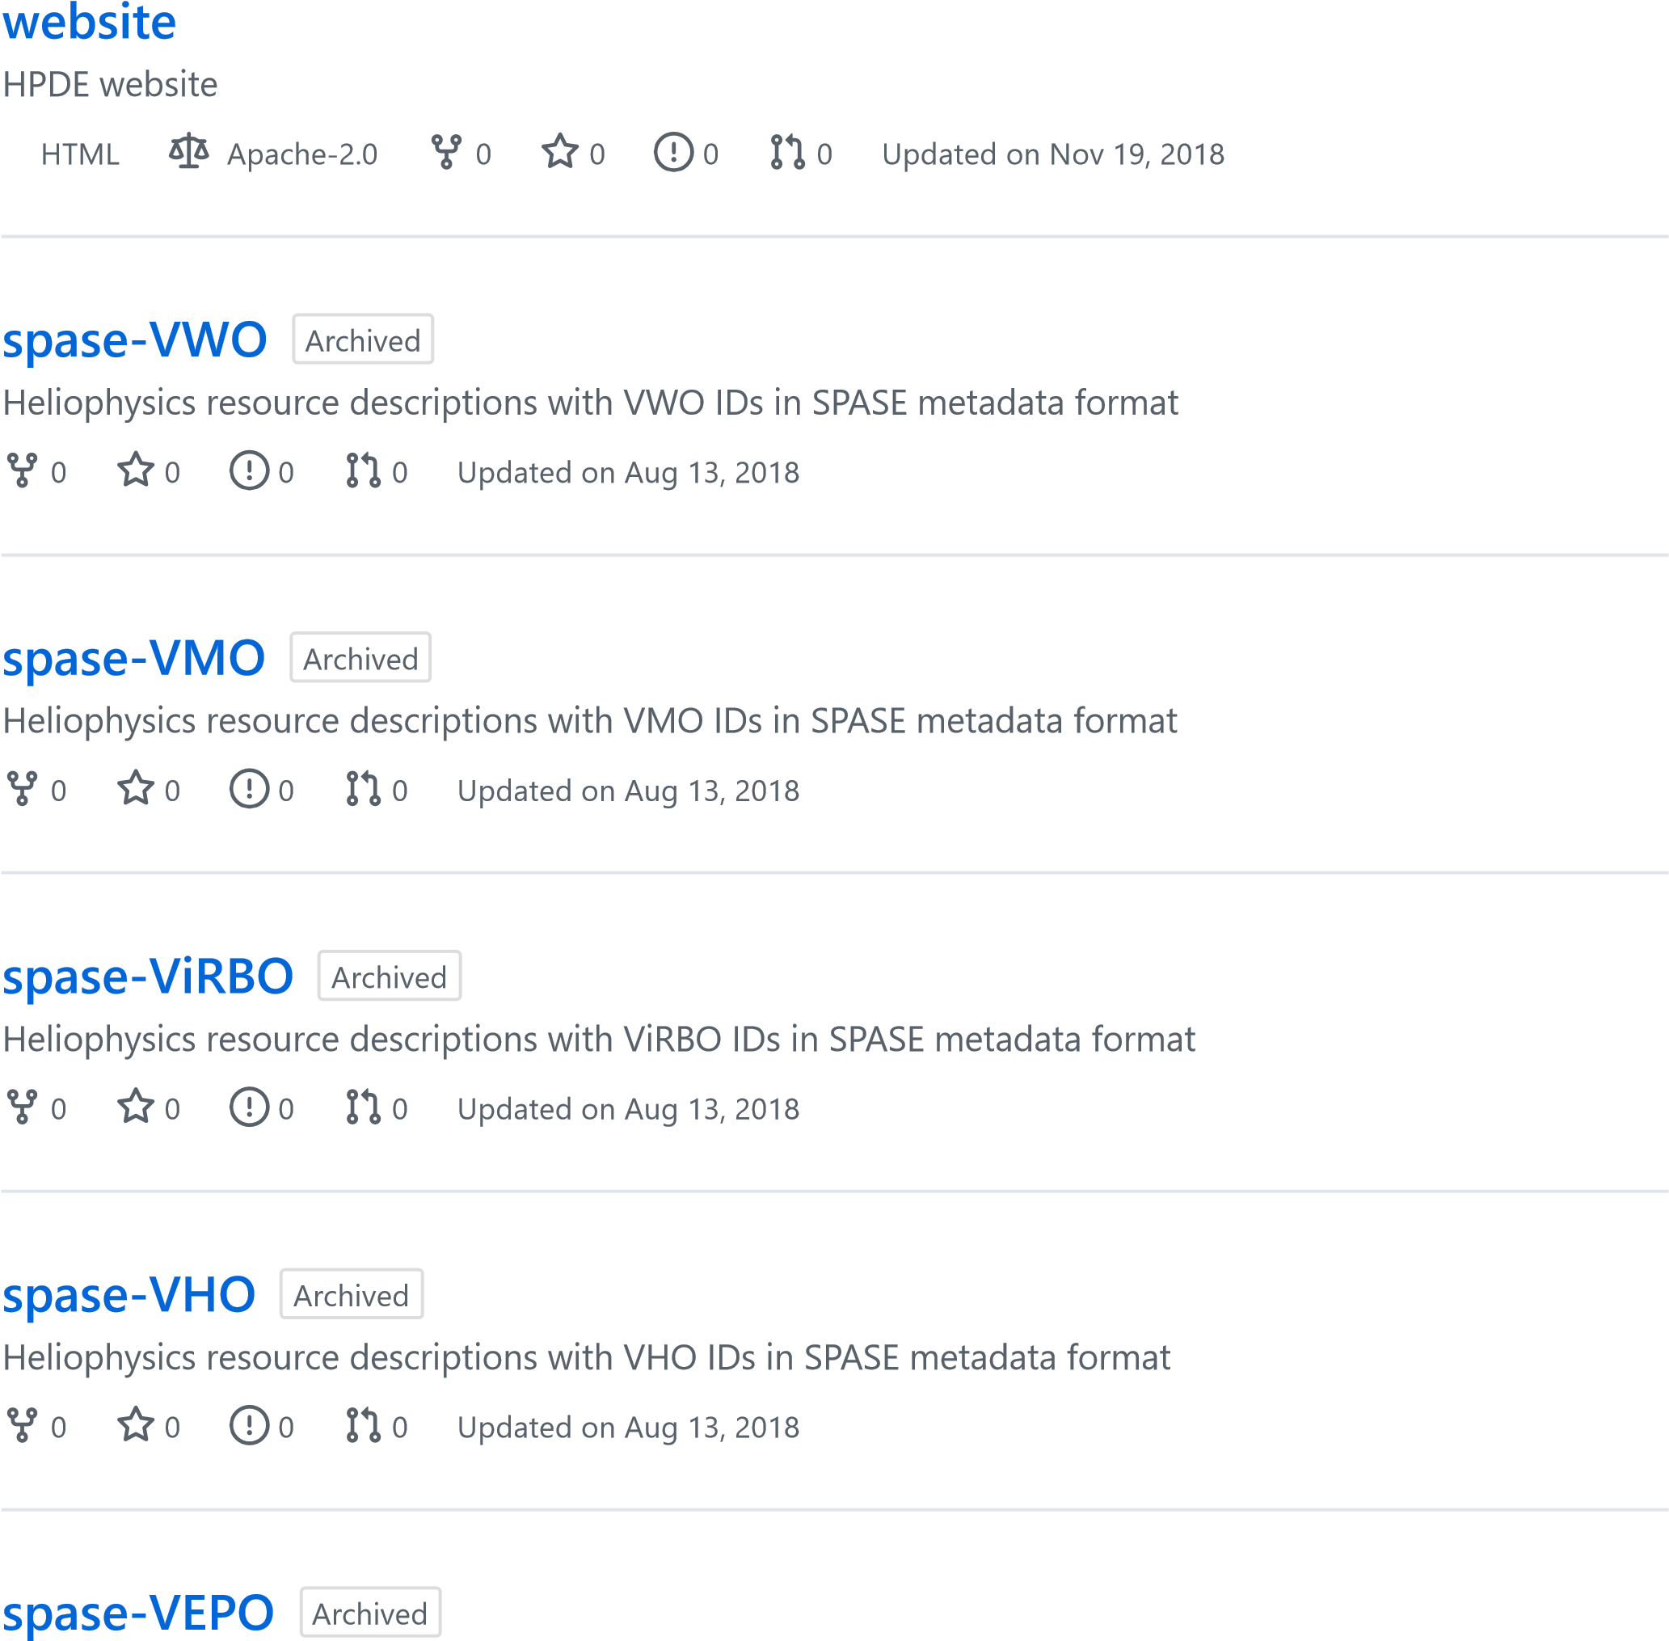

Heliophysics resource descriptions with VEPO IDs in SPASE metadata format

0

0

[0](https://github.com/hpde/spase-VEPO/issues)

[0](https://github.com/hpde/spase-VEPO/pulls)

Updated

on Aug 13, 2018

[**O**](https://github.com/hpde/spase-VITMO)

[**spase-VITM**](https://github.com/hpde/spase-VITMO)

Archived

Heliophysics resource descriptions with VITMO IDs in SPASE metadata format

0

0

[0](https://github.com/hpde/spase-VITMO/issues)

[0](https://github.com/hpde/spase-VITMO/pulls)

Updated

on Jan 18, 2018



## spase-group @spase-group

Space Physics Archive Search and Extract (SPASE) specifications, software and tools.

Owner: Todd

[**resource-tools-node**](https://github.com/spase-group/resource-tools-node)

A collection of tools for working with SPASE resource descriptions.

JavaScript

Apache-2.0

0

0

[0](https://github.com/spase-group/resource-tools-node/issues)

[1](https://github.com/spase-group/resource-tools-node/pulls)

Updated

on Nov 2, 2019

[**spase-model-tools**](https://github.com/spase-group/spase-model-tools)

Tools to generate usable expressions (i.e. XSD) of a data model specification.

Java

0

0

[0](https://github.com/spase-group/spase-model-tools/issues)

[0](https://github.com/spase-group/spase-model-tools/pulls)

Updated

on Oct 10, 2019

[**spase-base-model**](https://github.com/spase-group/spase-base-model)

Specification for the SPASE base information model.

TSQL

Apache-2.0

0

0

[0](https://github.com/spase-group/spase-base-model/issues)

[0](https://github.com/spase-group/spase-base-model/pulls)

Updated

on Oct 2, 2019

[**spase-sim-model**](https://github.com/spase-group/spase-sim-model)

Simulation extensions to the SPASE information model.

TSQL

Apache-2.0

0

0

[0](https://github.com/spase-group/spase-sim-model/issues)

[0](https://github.com/spase-group/spase-sim-model/pulls)

Updated

on Sep 26, 2019

[**registry-services**](https://github.com/spase-group/registry-services)

Servlets to provide a SPASE compliant registry services packaged as a deployable web application.

Java  [0](https://github.com/spase-group/registry-services/pulls)  Updated on Mar 3, 2016

[1](https://github.com/spase-group/registry-services/network/members)

[1](https://github.com/spase-group/registry-services/stargazers)

[0](https://github.com/spase-group/registry-services/issues)

[**resource-tools**](https://github.com/spase-group/resource-tools)

Collection of tools for procesisng and using SPASE description and SPASE services.

Java

0

[1](https://github.com/spase-group/resource-tools/stargazers)

[0](https://github.com/spase-group/resource-tools/issues)

[0](https://github.com/spase-group/resource-tools/pulls)

Updated

on Feb 10, 2016